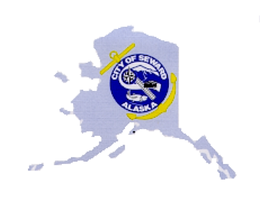
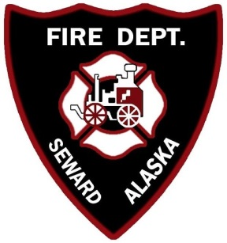
Seward Fire Department
PO Box 167
Seward, AK 99664
907-224-3445
sewardfd@cityofseward.net

NEWS RELEASE

For Immediate Release: Contact: Chief C. Crites
April 23, 2020 Phone: 907-224-3445

Seward Fire Department Holds Annual Awards Banquet Virtually

The Seward Fire Department celebrated another successful year of serving the community at its annual awards banquet Wednesday April 22nd 2020. Due to the circumstances surrounding the COVID-19, this year’s banquet was unique in that it was held entirely online via Zoom. Every year we honor the bravery, sacrifice, and dedication of our members through these awards; this year’s recipients are examples of these qualities. The awardees are nominated by their peers for exceptional service to their community during the previous year. “The City of Seward is fortunate to have these dedicated members that sacrifice their time and energy, selflessly, and I am lucky enough to call them my family, and I am proud of all their great accomplishments.” said Seward Fire Chief Clinton Crites.
The following individuals were recognized for their special achievements in 2019:
Firefighter of the Year: Lisa Musick
Distinguished Service Award: David Squires
Chief’s Award: Katrina Rix
Community Service Award, Individual Citizen: Mandy Jacobs
Community Service Award, Organization: ODOM Corporation, Tracy Estes
Most Calls Ran (195): Riley Shurtleff
Most Training Hours (382.35): Riley Shurtleff
The Seward Fire Department along with its dedicated volunteers responded to 300 calls for service in 2019. Not all volunteers are Firefighters, the fire department has non-certified (Auxiliary) members that assist with many other aspects of the department.
If you are interested in becoming a volunteer Firefighter or Auxiliary member please give us a call at 224-3445 or send us an email to Sewardfd@cityofseward.net. Men and women with almost every skill set are needed. We are always looking for new talent interested in giving back to their community.

###

